[Internet of Things in Emergency Management: Enhance Emergency management operation]

[Uzair]
Tuesday October 5, 2021

Internet of Things in Emergency Management: Enhance Emergency management operation

Abstract: cloud computing enabled IOT devices most effectively works as compare to industrial IOT system, Smart cities works better with the help of IOT devices, it enable the administrator of healthcare department to recover the health of patient due to detection of emergency alert detection, IOT system works on WI-FI network connected with smart phone to sending data. Qualitative research method used, data collected from reliable sources.
Keywords: emergency system, IOT emergency system, healthcare IOT system
Introduction
In emergency management in china during august 2009 (Ji & Anwen, 2010), conduct at Chinese premier the thought of sensing china premier, internet of things now is significant part of every domain, to secure every Govt. institution with the help of IOT devices. (L.Yang, S.H.Yang, & L.Plotnick, 2013) Since the IOT system was introduce in 2005, IOT system devices communicate with sensor system and directly connected with cellular phone, it also enable the user to bring emergency alert for any wrongdoing. IOT technology effectively used in every organization to recover the emergency quick response operation to handle situation and provide the facility to the user to handle the response. (Javaid & Khan, 2021) During the covid19 pandemic situation IOT system enable the healthcare department to manage organize and handle disaster recovery of corona virus patient. Various healthcare administrator deploy IOT devices to sense the COVID emergency and take decision accordingly, IOT system is best choice during covid19 operation in 2020 to manage the corona virus patient. IOT enabled the user to take decision of choice and handle the quick response, (Malik, Sharma, & Singh, 2021) various industrial application of IOT like automotive industry and environment monitoring, agriculture, construction, smart grid, healthcare. This research highlight the emergency response chain management system by using the internet enabled IOT system, IOT system uses WIFI technology and using internet connection connectivity which is connected by the each object in the domain.
Related Work
IOT devices enabled the organization to handle the disaster recovery system and manage the high risk environment in every situation (Thibaud, chi, & Zhou, 2018), this paper evaluate the IOT application in high risk management in health care department and recover the every disaster situation. IOT system significantly working on Gov. Healthcare department as well as to manage the operation of public safety in high risk environment as well as health and safety industries. IOT system implemented in food and supply chain system and mining and energy industries with intelligent transport system. Challenges exist to handle the emergency health system, future research required. IOT fit for task technology fit approach to handle the disaster management. (Sinha, kumar, & Rana, 2019) , results obtain from the PLS path modeling, with various disaster management location scenarios also highlighted. Task technology fit approach suitable approach to meet the emergency system. Road traffic accident has been increasing in advance countries due to less development of artificial intelligence detection system. Lack of medical transport is major issue, wireless sensor area networking including IOT devices enable the precise collection of data and increasing the demands at healthcare department. The patient care emergency system deployed at advanced countries.
Internet of things is novel paradigm of artificial intelligence research it connect any time anywhere and any devices using the wireless internet connection. It also connected with user mobile phone with sensor technology that provide instruction related to the required object such as any emergency threats of fire etc. IOT devices provide the system to overcome the critical situation (lu, papagiannidis, & Elefertheios, 2018)
Methods
The methodology of this research paper, based on qualitative research, secondary data has been collected from previous research publication:
Method of analysis: Quantitative analysis approach used.
Qualitative data question: how the internet of things technology can enhance emergency management operations. This question answered in research.
Result & Analysis
Cloud enabled IOT devices most effectively works together to meet the disaster and emergency challenges, various countries affected global occurrences technologies disaster analysis as follow:
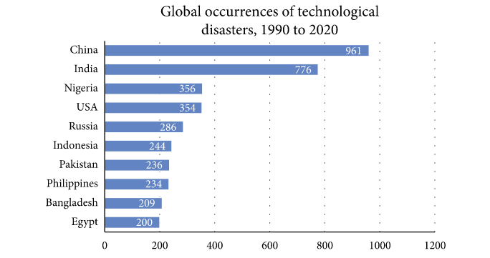
Figure 1: Top 10 disaster affected countries
The internet of things devices could be effective to recover and handle the emergency management system most effectively the above classification method based on IOT disaster recovery system.
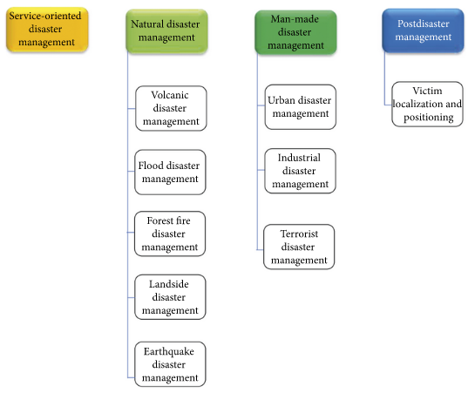
Figure 2: IOT based disaster recovery system (Classification method)
IOT internet of thing devices comparison table to communicate with the system, the solution is provided it also enabled the user to connect with hand held devices as well smart screen, it quickly available to all of the person.
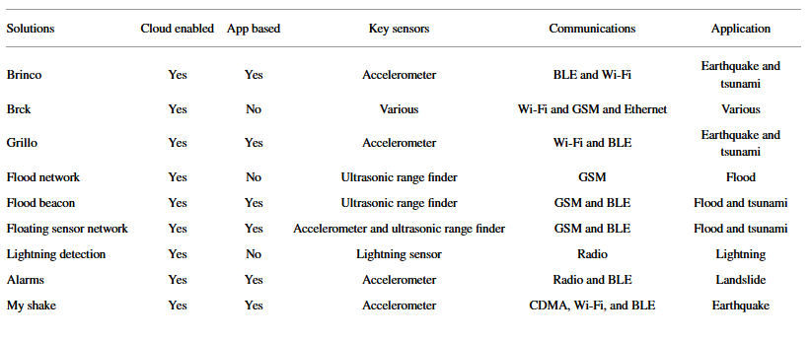
Table 1: Comparison between IOT enabled disaster management system
The support vector classification algorithm effectively method to evaluate and predict the various IOT technology which treat the emergency system effectively, such as medical, forest, road and food chain system. The basic component wireless radio mobile network signal that connect multifunction IOT system, it also design to meet the terrorist broadband system, based of RFID based localization rules with AND, OR fusion rules to overcome the detection of energy spectrum produced from the sufferers of mobile phone user.
Discussion
Advanced technology IOT system which used to overcome the emergency situation effectively, various IOT system (Sharma, Anand, & Sabrwal, 2021) IOT devices smartly connected to smart phone and meet the challenges of emergency management system, mostly in healthcare department needs IOT system to treat the patient without any delay. Mostly the IOT system required more signal for connectivity, such as wireless sensor network in remote areas needs more energy power and signal connectivity. (Bhosle, DB., & T., 2018) for emergency management the internet of thing devices proposed with sensor technology to upload the required data on cloud server, cloud server connected with smart phone, on the happening of emergency management recover system the GMAIL and telegram used to handle the system using the IFTTT software as service, the mission of smart cities to installing the IOT system on every point of city is another challenging question. The IOT devices uses the wireless sensor network to manage between the emergency systems.
Conclusion
Healthcare emergency department where the emergency occurred with patient condition it is detected and organized through the IOT devices. By installing IOT system in Gov. Hospital of public sector at advance country it enable the administrator to save the cost, time and patient health. The emergency alert generated by the IOT system without any delays such as on roads, to detection of accident, and on food chain to overcome the solution. IOT system works on WIFI network connected with internet, mostly the cloud computing enable IOT system is effectively work.

References

Bhosle, S. L., DB., S., & T., S. (2018). Disaster management system using IOT. International journal of research trends and innovation, 148-160.
Javaid, M., & Khan, I. H. (2021). Internet of things IOT enabled healthcare helps to take the challenge of covid19 pandemic . Journal of oral biology and Cranifacial research, 209-214.
Ji, Z., & Anwen, Q. (2010). The Application of internet of things (IOT) in emergency management system in china . 2010 IEEE international Conference on Technologies for Homeland security (HST) , 139-142.
L.Yang, S.H.Yang, & L.Plotnick. (2013). How the internet of things technology enhances emergency response operations. Technological forecasting and socail change, 1854-1867.
lu, Y., papagiannidis, S., & Elefertheios. (2018). Internet of things a systematic review of the business literature from the user and organisationa perspective. Technological forecasting and social change , 285-297.
Malik, P. K., Sharma, R., & Singh, R. (2021). Industrial internet of things and its applications in industry 4.0 state of the art. computer communication science direct, 125-139.
Sharma, K., Anand, D., & Sabrwal, M. (2021). A disaster management framework using internet of things based interconnected devices. mathematical problem in engineering, 1-20.
Sinha, A., kumar, P., & Rana, N. P. (2019). Impact of Internet of things IOT disaster management: a task technology fit perspective. Annals of operations research , 759-794.
Thibaud, M., chi, H., & Zhou, W. (2018). Internet of things IOT in high risk environment health and safety industries a comprehesive review. Decision support system, 79-95.

